System Requirements Statement (SRS) –

e-RTO

Doc. Ref. : SRS_v0.4.doc

Version : 0.4

Status : Drafted

Created by : Kenji Tanaka

Date : 04-Dec-2012

1. Introduction 4

2. Functional Requirements 5

2.1 CitizenModule 6

2.2 admin Module 8

2.3 message acknoeledgement Module 9

2.4 Use Case Diagram.............................................................................................................................9

THIS DOCUMENT CONTAINS 10 NUMBERED PAGES

# Introduction

e-RTO System is introduce to optimize desk work.

Now a day’s many people are purchasing two wheelers, four wheelers etc. So the RTO employees having lot of work burden of maintaining documentation.

License issue, registration process etc. which required lot of paper work. As a result people cannot get the things done in right time, which waste the time, money & energy. Similarly the vehicle owner sometimes forgets to carry the documents at the time of enquiry. So to overcome these drawbacks we are developing an enhanced e-RTO System.

Such like that we provide one type of environment which gives a user friendly means user can access and understand well.

Administrator has the power to verify the data entered by the user, processing of data and provide appropriate solutions.

The proposed system is aimed to automate the major processes in the Regional Transport Office.

# Functional Requirements

The Account part of e-RTO System has two modules which are divided 10 processes described as below.

|  |  |  |
| --- | --- | --- |
| **No** | **BRS requirement ID** | **Description** |
| **2.1** | **Citizen Module** | |
| **2.1.1** | **F1** | **Register** |
| **2.1.2** | **F2** | **Login Process** |
| **2.1.3** | **F3** | **Apply for Learning Licence** |
| **2.1.3** | **F4** | **Apply for Permanent Licence** |
| **2.1.4** | **F5** | **Upload Documents** |
| **2.1.6** | **F6** | **Choose Date and Slot for Online Test** |
| **2.1.7** | **F6** | **Appear for Mock Test** |
| **2.1.8** | **F7** | **Track Application Status** |
| **2.1.9** | **F8** | **Logout** |
| **2.2 Staff Module** | | |
| **2.2.1** | **F21** | **Login Process** |
| **2.2.2** |  | **Update Profile** |
| **2.2.3** | **F22** | **View applications for Learning Licence** |
| **2.2.4** | **F23** | **View applications for Permanent Licence** |
| **2.2.5** | **F24** | **Update application status** |
| **2.2.6** | **F25** | **Logout** |
| **2.3 Admin Module** | | |
| **2.3.1** | **F31** | **Login Process** |
| **2.3.2** | **F32** | **Create staff account** |
| **2.3.3** | **F33** | **Logout** |

## 2.1 Citizen Module

* Citizen is the user of system who is going to apply for licence.

### 2.1.1 Account Creation Process

* E-RTO System compels to create the account before using it. So, e-RTO System should provide the function which makes citizen creates new account.
* When citizen creates new account, the function demands information described as below.

1. Login information

* The Login information

The Login information consists of some items described as below.

1. First Name
2. Last Name
3. E-mail ID
4. Password
   * Password

* The Password has constrains which makes the Password consists of more than or equal 8 and less than or equal 16 characteristics including characters described as below.

1. Numeric figure (at least one)
2. Capital alphabet (A-Z)(at least one)
3. Small alphabet (a-z)(at least one)
4. Special character (#, $, %, &, etc.) (at least one)

The Password must be encrypted in e-RTO System.

### Login Process

* e-RTO System always compels user authentication before using itself except when a new account is successfully created.
* The user authentication demands Email ID and Password. The Email ID and the Password should be checked in two ways.
  + First, The Email ID and the Password should be existed and correct.
* If The Email ID and the Password are not equal to what the user has registered, the user authentication cannot be provided.
  + Second, Email ID and Password are not correct .
* If The Email ID and Password is not correct the citizen has to go through the registration process again .
* The citizen account will be alive up till he doesn't logout from the system.

**2.1.3 Applying For licence**

* After login Process citizen lands on the licence page
* First, the citizen has got two option to choose between learning and permanent licence
* If he choose to apply learning licence then he/she have to fill up the given form .
* The citizen has to provide his /her Aadhar Card details .
* The citizen has to fill his/her correct and existing contact no.
* The citizen has to fill his/her correct Date of Birth
* The citizen has option to choose his/her Gender .
* The citizen has to fill his/her Blood Group.
* The citizen has to mention his/her Identification mark .
* The citizen has to provide the Address in the form of Landmark, Street name, Village/city, Pin code ,District and State.

**2.1.4. Upload Documents**

* The citizen has to submit his/her documents.

**2.1.5 Choose Date and Slot for Online Test**

* Citizen has to choose date and Time slot for Online test.
* If that test slot is not available then citizen has to choose different date and time slot.
* Each day will have 3 slots and each slot can have 10 applicants.
* Citizen will have the right to choose Test date and slot as per his convenience but Test date will be 7 days prior to Application field.
* The Mock Test contains 20 question.
* Every question will judge the citizen knowledge regarding Traffic Rules and Road signs .

**2.1.5 Appear for Mock Test**

* Citizen can appear for mock test anytime.
* The Mock Test contains 20 question.

**2.1.6 Track the Application Status**

* The request pending ,accepted or denied will be displayed in the status
* All the information related to Test Date and Test Slot will be displayed in the status .
* All the staff action related to process will be displayed in the status

#### 2.2 RTO Staff Module

**• RTO Staff** should be responsible for following activities**,**

### 2.2.1 Login Process

* E-RTO System always compels user authentication before using itself except when a new account is successfully created.
* The user authentication demands User-ID and Password.
* Staff account will be created by Admin itself , without admin no one as a right to create account for staff .
* The User-ID and the Password should be existed and correct.
* If the User-ID and the Password are not equal to what the Admin has registered ,the staff authentication cannot be provided.
* The Staff account should alive for so long as he doesn't logout from the system .

### 2.2.2 Update Profile

* Staff can update his/her basic information.
* Staff can also change his/her Password.

### 2.2.2 View applications for Learning Licence List

* The learning list which is under staff has an information of citizen who has requested for a licence.
* RTO staff can view List of applications by filtering as per need.
* Filter consist of
  + 1. All Applications
    2. By Date
    3. Confirmed Applications
    4. Pending Applications
    5. Rejected Applications
* Information of citizen contain his/her first name, last name ,email, Aadhaar No, Mobile No ,Birth Date, Gender, Blood Group, Identification Mark, Address, and most important the Documents Uploaded by citizen.
* In this list there is an option of Application Status which is managed by RTO Staff .
* Once RTO officer changes status to **SlotBooked** Citizen will be notified with mail and Test Slot gets Booked.

### 2.2.3 View applications for Permanent Licence List

* The Permanent list which is under RTO Staff has an information of citizen who has requested for a licence.
* RTO staff can view List of applications by filtering as per need.
* Filter consist of

All Applications

By Date

Confirmed Applications

Pending Applications

Rejected Applications

* Information of citizen contain his/her first name, last name ,email, Aadhaar No, Mobile No ,Birth Date, Gender, Blood Group, Identification Mark, Address, and most important the Test Date and Time selected by them as per their own convenience.
* In this list there is an option of Application Status which is managed by RTO Staff .
* Once RTO officer changes status to **SlotBooked** Citizen will be notified with mail and Driving Slot gets Booked.

### 2.2.4 Update application Status

* RTO Staff can update the status of application after document verification.
* The information staff could update is described below for Learning License.
  + - 1. Completed
      2. SlotBooked
      3. WrittenTestPassed
      4. WrittenTestFailed
      5. Rejected
* The information staff could update is described below for Permanent License.

1. Completed
2. SlotBooked
3. DrivingTestPassed
4. DrivingTestFailed
5. Rejected
   * Staff can save updated status.
   * The update status related to the appointment will be send via email to the citizen .

#### 2.3 Admin Module

### 2.3.1 Login Process

• E-RTO System always compels user authentication before using itself except when a new account is successfully created.

• The user authentication demands Email ID and Password. The Email ID and the Password should be checked in two ways.

* First, The Email ID and the Password should be existed and correct.

1.If The Email ID and the Password are not equal to what the admin has registered, the Admin authentication cannot be provided.

* Second, the User Type linked to the Email ID should be "Admin".

2.When the Email Type is "Admin", user can be placed on “Admin Home”.

• The Admin account should alive for so long as he doesn't logout from the system .

### 2.3.2 Create the staff account

* Only Admin has right to create account for staff .
* Admin will Create the Account for RTO staff which contains First name , Last Name , User-ID and default password.
* User-Id will be unique for each RTO Staff.
* If user-Id is already used then Admin will have to choose another User-id.
* Using this User-id and password RTO Staff can Login and update his/her profile and can change password.

#### 2.4 Use Case Diagram

**Admin:**

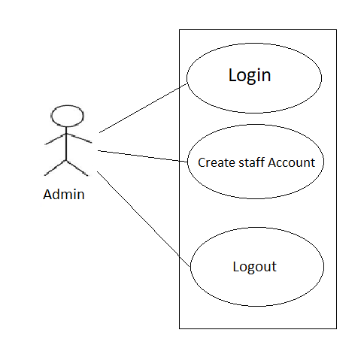

*Fig. Use case diagram for admin*

1. In Admin use case diagram Admin is the Actor.
2. Admin can handle following use cases:
3. Login
4. Create staff account

**Staff:**

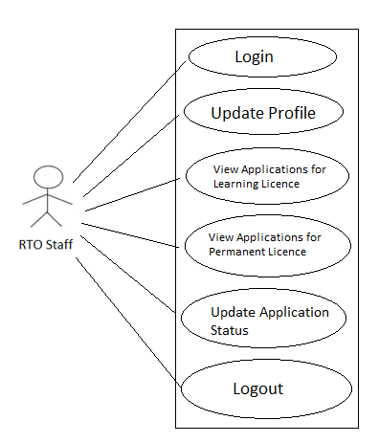

*Fig. Use case diagram for RTO Staff*

1. In Staff use case diagram staff is the Actor.
2. Staff can handle following use cases:
3. Login
4. View applications for Learning licence List
5. View applications for Permanent Licence List
6. Update Application Status

**Citizen:**

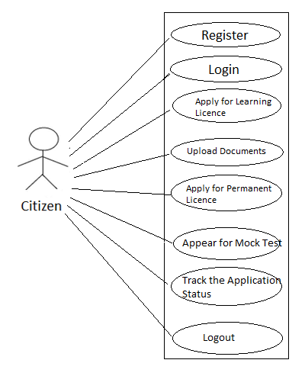

*Fig. Use case diagram for Citizen*

1.In citizen use case diagram citizen is the Actor.

2.Citizen can handle following use cases:

a. Register

b. Login

c. Apply for learning licence

d. Update Document

e. Apply for permanent licence

f. Appear for Mock Test

g. Track the Application Status

h. Logout